## Mysql server password is root123

\c can be used to return to my sql prompt

## What is SQL?

SQL is a short-form of the structured query language, and it is pronounced as S-Q-L or sometimes as See-Quell.

This database language is mainly designed for maintaining the data in relational database management systems. It is a special tool used by data professionals for handling structured data.

SQL Commands

* SQL commands are instructions. It is used to communicate with the database. It is also used to perform specific tasks, functions, and queries of data.
* SQL can perform various tasks like create a table, add data to tables, drop the table, modify the table, set permission for users.

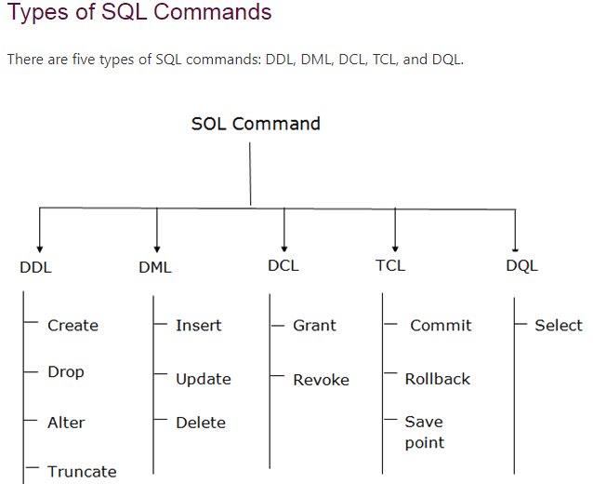

### ****DDL (Data Definition Language):****

[DDL](https://www.geeksforgeeks.org/features-of-structured-query-language-sql/) or Data Definition Language actually consists of the SQL commands that can be used to define the database schema. It simply deals with descriptions of the database schema and is used to create and modify the structure of database objects in the database. DDL is a set of SQL commands used to create, modify, and delete database structures but not data.

List of DDL commands:

* [**CREATE**](https://www.geeksforgeeks.org/sql-create/): This command is used to create the database or its objects (like table, index, function, views, store procedure, and triggers).
* [**DROP**](https://www.geeksforgeeks.org/sql-drop-truncate/): This command is used to delete objects from the database.
* [**ALTER**](https://www.geeksforgeeks.org/sql-alter-add-drop-modify/)**:**This is used to alter the structure of the database.
* [**TRUNCATE**](https://www.geeksforgeeks.org/sql-drop-truncate/)**:**This is used to remove all records from a table, including all spaces allocated for the records are removed.
* [**COMMENT**](https://www.geeksforgeeks.org/sql-comments/): This is used to add comments to the data dictionary.
* [**RENAME**](https://www.geeksforgeeks.org/sql-alter-rename/)**:**This is used to rename an object existing in the database.

**Syntax**:

* CREATE DATABASE database_name;

**database_name**: name of the database.

**Example Query:**  
This query will create a new database in SQL and name the database as *my_database*.

CREATE DATABASE my_database;

* Use my_database;
* CREATE TABLE table_name

(

column1 data_type(size),

column2 data_type(size),

column3 data_type(size),

....

);

CREATE TABLE Students

(

ROLL_NO int(3),

NAME varchar(20),

SUBJECT varchar(20),

);

**DROP**

* **DROP is used to delete a whole database or just a table.The DROP statement destroys the objects like an existing database, table, index, or view.**

**DROP object object_name**

**Examples:**

**DROP TABLE table_name;**

**table_name**: Name of the table to be deleted.

**DROP DATABASE database_name;**

**database_name**: Name of the database to be deleted.

* **ALTER TABLE is used to add, delete/drop or modify columns in the existing table. It is also used to add and drop various constraints on the existing table.**

**1] ALTER TABLE – ADD**

**ALTER TABLE table_name**

**ADD (Columnname_1 datatype,**

**Columnname_2 datatype,**

**…**

**Columnname_n datatype);**

**2]** **ALTER TABLE – DROP**

DROP COLUMN is used to drop column in a table. Deleting the unwanted columns from the table.

**Syntax:**

**ALTER TABLE table_name**

**DROP COLUMN column_name;**

**3] ALTER TABLE-MODIFY**

It is used to modify the existing columns in a table. Multiple columns can also be modified at once.  
*\*Syntax may vary slightly in different databases.*

**Syntax(Oracle,MySQL,MariaDB):**

**ALTER TABLE table_name**

**MODIFY column_name column_type;**

**Syntax(SQL Server):**

**ALTER TABLE table_name**

**ALTER COLUMN column_name column_type;**

**4] ALTER TABLE- Rename**

**ALTER TABLE table_name**

**RENAME TO new_table_name;**

**4] ALTER TABLE- Rename column name**

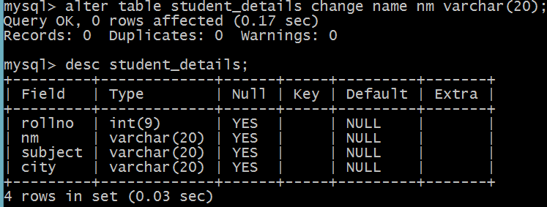

**5] SQL - TRUNCATE TABLE Command**

The SQL **TRUNCATE TABLE** command is used to delete complete data from an existing table.

You can also use DROP TABLE command to delete complete table but it would remove complete table structure form the database and you would need to re-create this table once again if you wish you store some data.

## Syntax

The basic syntax of a **TRUNCATE TABLE** command is as follows.

TRUNCATE TABLE table_name;

# DML Commands in SQL

DML is an abbreviation of **Data Manipulation Language**.

The DML commands in Structured Query Language change the data present in the SQL database. We can easily access, store, modify, update and delete the existing records from the database using DML commands.

**6] The SQL INSERT INTO Statement**

## INSERT INTO table_name VALUES (value1, value2, value3, ...);

**Inserting multiple rows with single insert query**

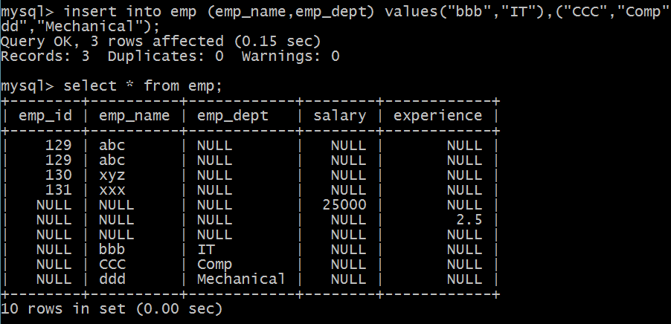

## 7] SQL DELETE Statement

## DELETE FROM table_name WHERE condition;

## 8]The SQL UPDATE Statement

UPDATE table_name  
SET column1 = value1, column2 = value2, ...  
WHERE condition;

## 9]Syntax of SELECT DML command

1. **SELECT** column_Name_1, column_Name_2, ….., column_Name_N **FROM** Name_of_table;
2. **SELECT** * **FROM** table_name;

## 10] To re-order columns in MySQL, use the ALTER TABLE MODIFY COLUMN. The syntax is as follows –

ALTER TABLE yourTableName MODIFY COLUMN yourColumnName data type after yourColumnName.

To understand the above syntax, let us first create a table. The query to create a table is as follows.

mysql> create table reOrderColumn

-> (

-> ProductId int,

-> DeliveryDate datetime,

-> ProductName varchar(100)

-> );

Query OK, 0 rows affected (0.76 sec)

Now check the description of the table. The query is as follows.

mysql> desc reOrderColumn;

The following is the output.

+--------------+--------------+------+-----+---------+-------+

| Field | Type | Null | Key | Default | Extra |

+--------------+--------------+------+-----+---------+-------+

| ProductId | int(11) | YES | | NULL | |

| DeliveryDate | datetime | YES | | NULL | |

| ProductName | varchar(100) | YES | | NULL | |

+--------------+--------------+------+-----+---------+-------+

3 rows in set (0.10 sec)

Now re-order the column using ALTER MODIFY command. I will reorder the DeliveryDate column after the **ProductName** column. The query is as follows.

mysql> alter table reOrderColumn modify column DeliveryDate datetime after ProductName;

Query OK, 0 rows affected (1.61 sec)

Records: 0 Duplicates: 0 Warnings: 0

Let us now check the column have been reordered or not. The query is as follows.

mysql> desc reOrderColumn;

The following is the output displaying the columns have been reordered.

+--------------+--------------+------+-----+---------+-------+

| Field | Type | Null | Key | Default | Extra |

+--------------+--------------+------+-----+---------+-------+

| ProductId | int(11) | YES | | NULL | |

| ProductName | varchar(100) | YES | | NULL | |

| DeliveryDate | datetime | YES | | NULL | |

## 11]After with Add

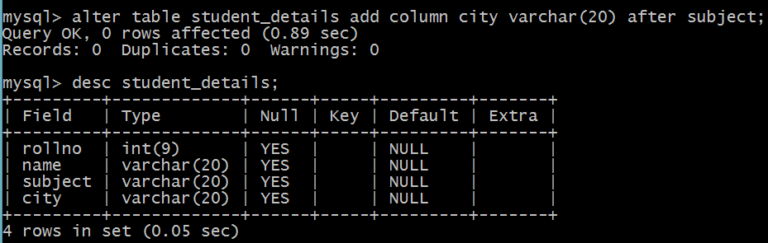

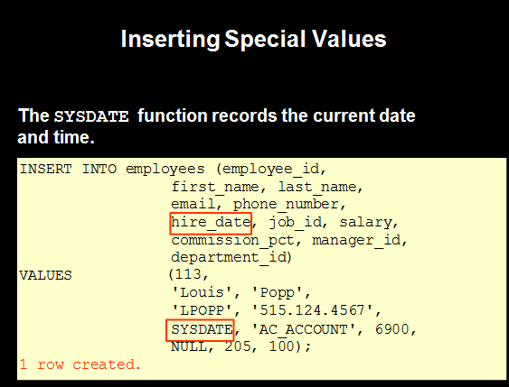

## SQL PRIMARY KEY Constraint

The PRIMARY KEY constraint uniquely identifies each record in a table.

Primary keys must contain UNIQUE values, and cannot contain NULL values.

A table can have only ONE primary key; and in the table, this primary key can consist of single or multiple columns (fields).

CREATE TABLE Persons (

ID int NOT NULL,

LastName varchar(255) NOT NULL,

FirstName varchar(255),

Age int,

    CONSTRAINT PK_Person PRIMARY KEY (ID,LastName)

);

OR

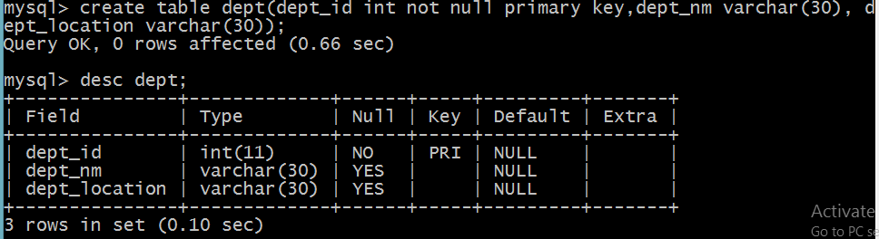

## SQL PRIMARY KEY on ALTER TABLE

ALTER TABLE Persons

ADD CONSTRAINT PK_Person PRIMARY KEY (ID,LastName);

## DROP a PRIMARY KEY Constraint

ALTER TABLE Persons

DROP PRIMARY KEY;

## SQL FOREIGN KEY on CREATE TABLE

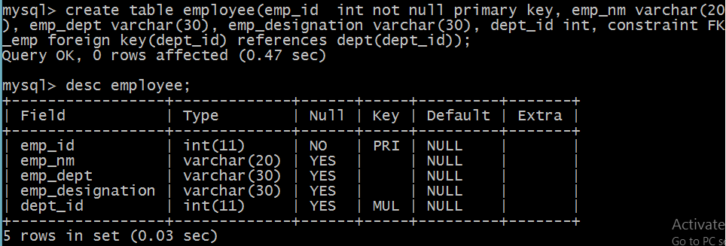

## SQL FOREIGN KEY on ALTER TABLE

## ALTER TABLE Orders ADD FOREIGN KEY (PersonID) REFERENCES Persons(PersonID);

## DROP a FOREIGN KEY Constraint

ALTER TABLE Orders  
DROP FOREIGN KEY FK_PersonOrder;

## AUTO INCREMENT Field

Auto-increment allows a unique number to be generated automatically when a new record is inserted into a table.

Often this is the primary key field that we would like to be created automatically every time a new record is inserted.

CREATE TABLE Persons (  
    Personid int NOT NULL AUTO_INCREMENT,  
    LastName varchar(255) NOT NULL,  
    FirstName varchar(255),  
    Age int,  
    PRIMARY KEY (Personid)  
);

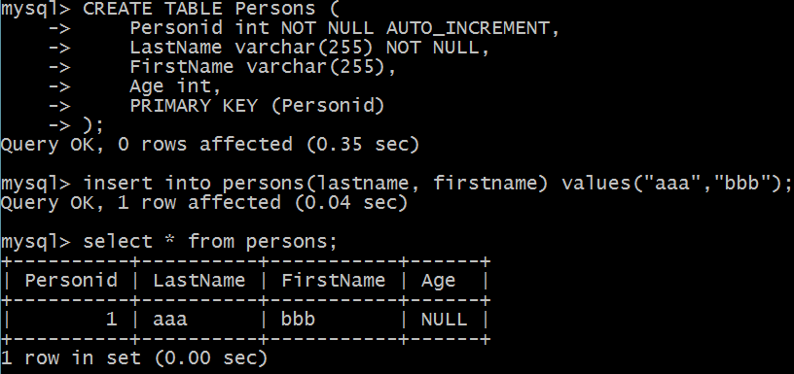

**Salary – Numeric datatype**

